**College of Professional Studies**

**Northeastern University San Jose**

**MPS Analytics**

**Course: : ITC 6000 - Database Management Systems**

**Assignment:**

Final Project - Data Import

**Submitted on:**

December 15, 2022

**Submitted to:**  **Submitted by:**

Professor: VENKATA DUVVURI NIKSHITA RANGANATHAN

**Project Name: Generation of a Machine learning data model to predict the average room rate for hotel booking using an Autonomous Database in Oracle Cloud**

**INTRODUCTION**

Oracle Auto ML is a cloud-based machine learning platform that enables users to build, train, and deploy machine learning models quickly and easily. It automates the process of feature engineering, model selection, and hyperparameter tuning, allowing users to focus on the business problem instead of the technical details. It also provides a graphical user interface to help users visualize their data and model performance. It offers a range of security features to help protect user data and models.

Oracle AutoML supports a variety of popular machine-learning algorithms, including linear regression, logistic regression, decision trees, and neural networks. Oracle Auto ML can be used for a variety of tasks such as predicting customer churn, forecasting sales, and detecting fraud. We would like to demonstrate how to use Oracle machine learning to import, analyze, and utilize data in our final project.

**About this Dataset:** The dataset considered is based on Hotel Booking Demand. This dataset comprises of hotel booking details of 32 attributes and 119390 data observations for both city hotels and resort hotels from July 2015-Aug 2017. The data set contains data such as booking date, reservation status, length of stay, customer type, country, required car parking spaces, number of special requests, etc. The data that is used within the project is sourced from [*Kaggle*](https://www.kaggle.com/datasets/jessemostipak/hotel-booking-demand) by the data owner, Jesse Mostipak.

The purpose of our project is to find the variables that affect the average daily rate of hotel rooms and to predict the daily average rate of rooms for hotel reservations. using machine-learning data models.

**DATA IMPORT**

**Access to data load system**

* Find the DATA LOAD on Database Actions l Launchpad.
* Click on local file

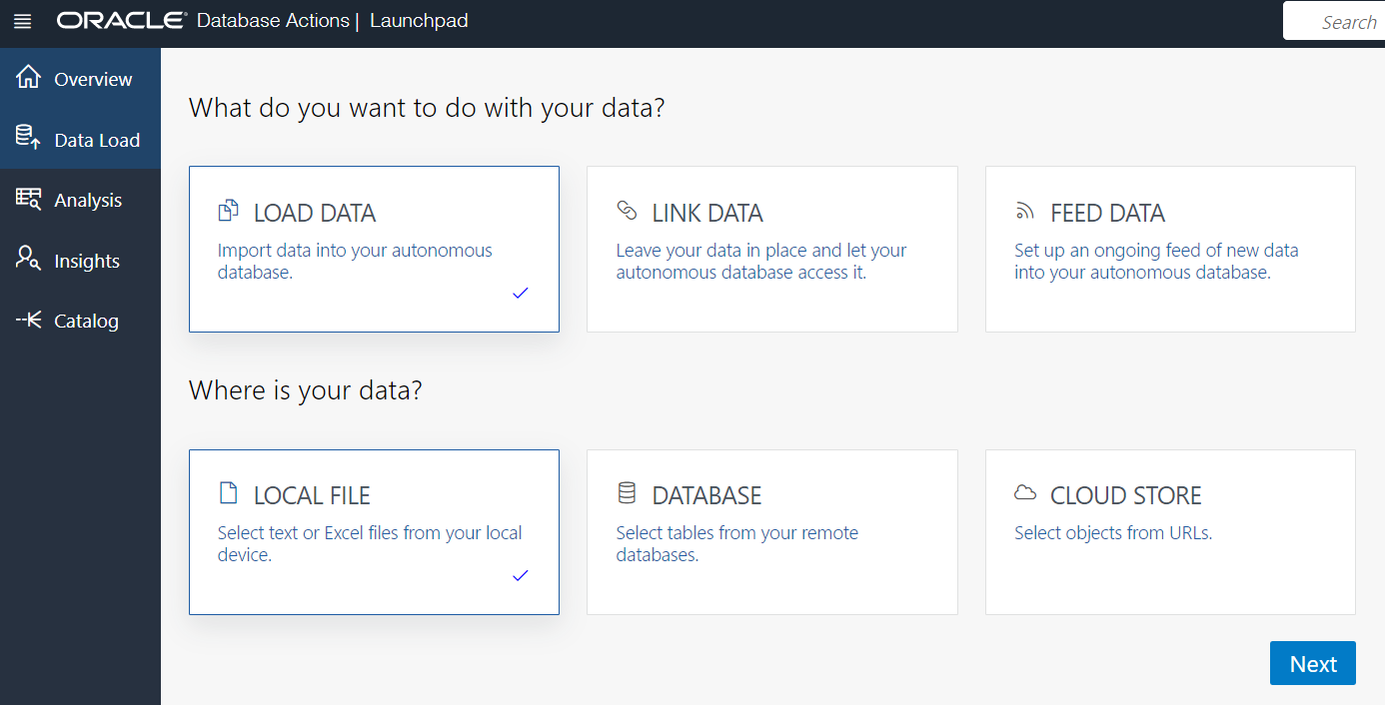

Click Next to upload your file

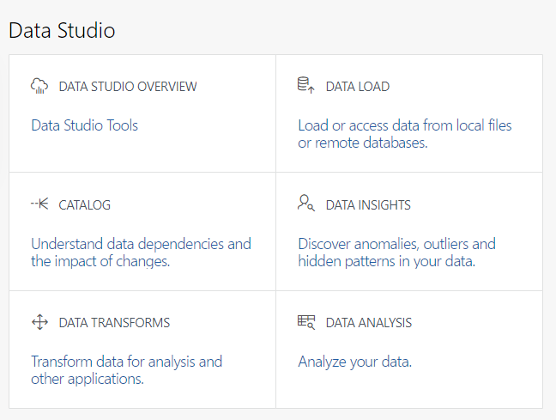





* Upload data 텍스트이(가) 표시된 사진

  자동 생성된 설명

Click Select Files to choose file



File you choose is shown

Click here to start upload

* **Check uploaded data**

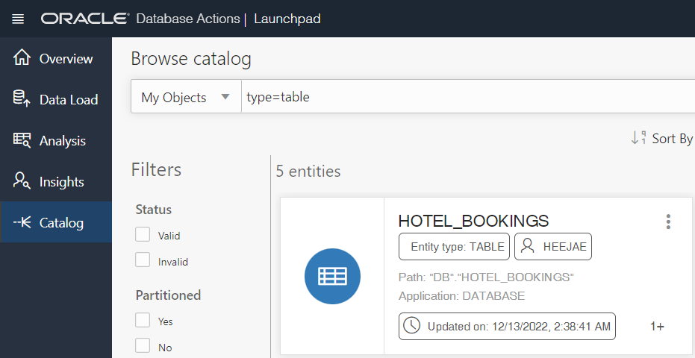

In Catalog menu

Enter ‘type=table’



Click here to see dataset



Checking dataset with several menus

Statistics about dataset

**CONCLUSION**

Oracle Machine Learning (OML) is a powerful tool for data analysis. It enables users to create predictive models and uncover insights from data quickly and easily. OML provides a comprehensive set of algorithms, tools, and visualizations to help users explore, analyze, and gain insights from their data. OML can be used in organizations to identify patterns in data, predict future outcomes, and make better decisions. It can also help organizations to automate processes, reduce costs, and improve customer experiences. We were able to understand how to import data to Oracle cloud and describe several important executions through this data import project. Based on this knowledge, we would like to develop a guideline that can help those who are interested in learning Oracle Machine learning in our final presentation.